1. 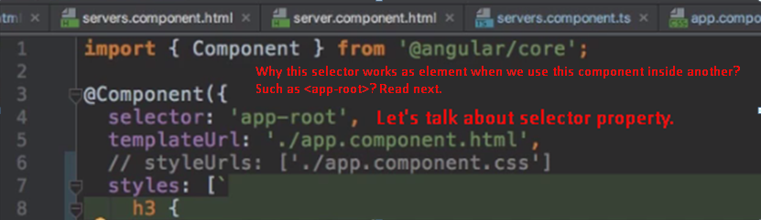
2. **Why selector:’app-root’ works as element as <app-root>**?
   1. See, when we select element in CSS, how do we write?
   2. **Example**: h1{…} 🡸 here we’re using css selector h1 which is tag selector means h1 represents <h1> tags. Same is when selector:’app-root’. It works as tag.
   3. **So,** you’re not limited to selecting by elements.
3. Another forms of selectors in component class.   
   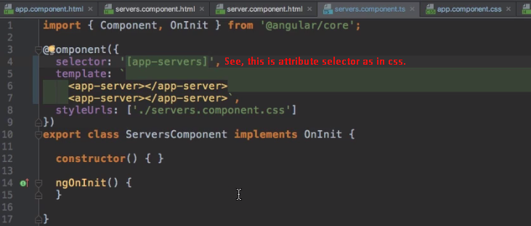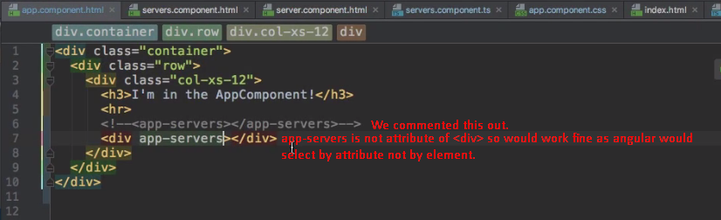
4. **Another example**:   
   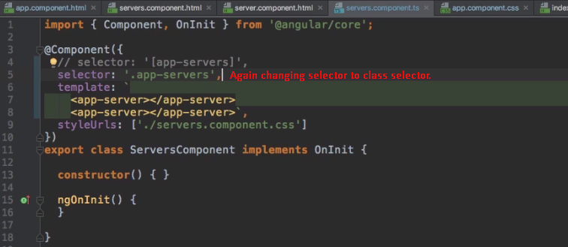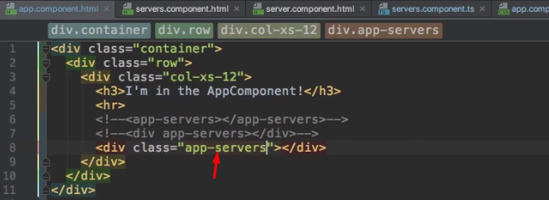  
   **NOTE**: ID selector and pseudo-selectors such as hover would not work
5. **Recommended Selector**: Element Selector rather than class or attribute selectors.